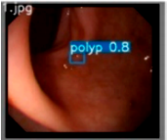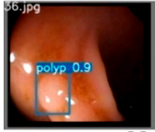
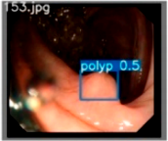 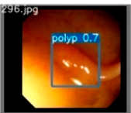 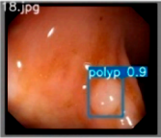 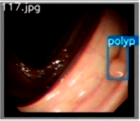Computers in Biology and Medicine 2021

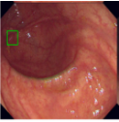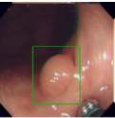

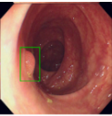 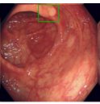 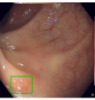 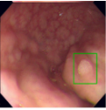Medical Image Analysis 2022
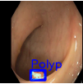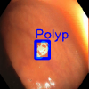
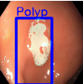 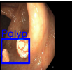 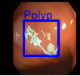 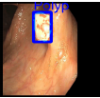British Machine Vision Conference 2018

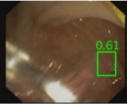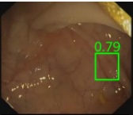
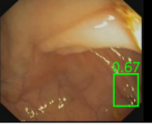 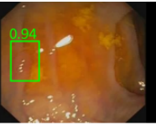 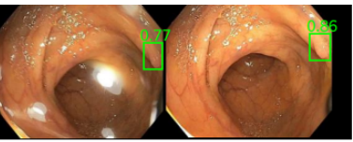 MICCAI 2021

A robust real-time deep learning based automatic polyp detection system（Computers in Biology and Medicine 2021）
Pacal I, Karaboga D. A robust real-time deep learning based automatic polyp detection system[J]. Computers in Biology and Medicine, 2018, https://doi.org/10.1016/j.compbiomed.2021.104519(134):104519.

Polyp detection on video colonoscopy using a hybrid 2D_3D CNN Medical Image Analysis 2022
Juana.González-Bueno Puyal, Brandao P , Ahmad O F ,et al.Polyp detection on video colonoscopy using a hybrid 2D/3D CNN[J].Medical image analysis, 2022, 82:102625.DOI:10.1016/j.media.2022.102625.

c) Y-Net: A deep Convolutional Neural Network for Polyp Detection 2021
Mohammed A K , Yildirim S , Farup I ,et al.Y-Net: A deep Convolutional Neural Network for Polyp Detection[C]//British Machine Vision Conference.2018.

d)Multi-frame Collaboration for Effective Endoscopic Video Polyp Detection via Spatial-Temporal Feature Transformation MICCAI 2021
Lingyun W, Zhiqiang H, Yuanfeng J, etal. Multi-frame Collaboration for Effective Endoscopic Video Polyp Detection via Spatial-Temporal Feature Transformation[C]. //de Bruijne, Marleen.Medical Image Computing and Computer Assisted Intervention -- MICCAI 2021, Springer International Publishing, 2021:302-312.

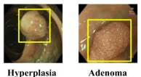
AI-doscopist: a real-time deep-learning-based algorithm for localising polyps in colonoscopy videos with edge computing devices
Poon, C.C.Y., Jiang, Y., Zhang, R. et al. AI-doscopist: a real-time deep-learning-based algorithm for localising polyps in colonoscopy videos with edge computing devices. npj Digit. Med. 3, 73 (2020). https://doi.org/10.1038/s41746-020-0281-z
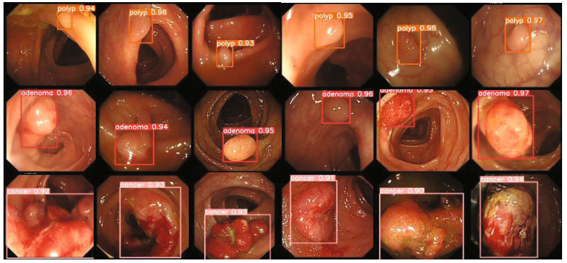

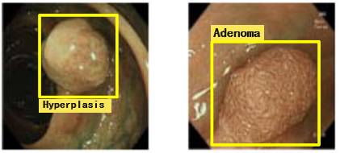
White-Light Endoscopic Colorectal Lesion Detection Based on Improved YOLOv5
Gao, Junbo. , et al. "White-Light Endoscopic Colorectal Lesion Detection Based on Improved YOLOv5." Computational and mathematical methods in medicine 2022(2022):9508004.

图二
A
只检测不分类
二分类
B

B.分类不具有区分性
B.假阳误报
图一
A.传统的检测方法
B.我们的方法

